
Generative Models vs Traditional AI-Driven Anomaly Detection in Large-Scale System Logs – A Comparative Study
Thesis Report

March 7, 2026
Fall 2024 Air University
Muhammad Asad Mahmood Khan Roll # 243260 MSAI-3

Abstract
The increasing complexity of distributed systems such as Hadoop (HDFS), Spark, and OpenStack has rendered manual log monitoring obsolete. This research proposes a comprehensive comparative study evaluating Traditional Machine Learning (ML), Deep Learning (DL), and Generative AI models for the automated detection of system anomalies within large-scale log collections. Initial benchmarking reveals that traditional supervised algorithms achieve high precision on structured data but rely heavily on labor-intensive manual feature engineering and demonstrate poor generalization across different system architectures. Furthermore, traditional unsupervised methods like Isolation Forest have shown significantly lower efficacy, highlighting a critical gap in detecting unknown errors. The primary objective of this thesis is to transcend these limitations by validating Generative Deep Learning architectures. This study aims to prove that Generative AI provides a superior balance of automation and accuracy, capable of generalizing across heterogeneous environments without the extensive manual retraining required by traditional ML approaches.

Chapter 1: Introduction
1.1 Background
System logs serve as the primary source of truth for diagnosing failures in cloud infrastructure. In distributed environments, a single user request triggers execution traces across thousands of nodes, generating massive volumes of unstructured data. As systems scale, the variety and volume of these logs make manual rule-based detection impossible.
1.2 Problem Statement
Current industry standards for log analysis face a functional dichotomy:
- Brittleness of Supervised ML: Traditional models like SVM and XGBoost offer high accuracy but are fundamentally brittle. They require rigid, manual feature extraction that fails catastrophically when log syntax changes or when models are ported to new systems.
- Inefficacy of Unsupervised Baselines: Unsupervised methods struggle to capture complex sequential dependencies, resulting in poor detection rates for unknown error patterns. There is a critical lack of a unified framework that combines the high accuracy of supervised learning with the flexibility of unsupervised discovery.
1.3 Objectives
This research aims to:
- Benchmark traditional supervised and unsupervised models on the HDFS dataset to establish a baseline for known error detection.
- Evaluate discriminative Deep Learning (DL) sequence models for anomaly detection without manual feature extraction.
- Validate Generative AI architectures to determine their superiority in detecting unknown anomalies and their capability to generalize across platforms.
- Conduct a tri-fold comparative study producing a definitive performance matrix comparing ML, DL, and Generative AI.
1.4 Research Questions
- RQ1: To what extent can Generative AI architectures generalize anomaly detection across heterogeneous distributed systems (e.g., from HDFS to Spark) compared to brittle Traditional Supervised models?
- RQ2: Can Generative Deep Learning models eliminate the dependency on manual feature engineering required by traditional AI, while maintaining high F1-scores?
- RQ3: Can deep generative models significantly outperform traditional unsupervised baselines in detecting unknown 'zero-day' anomaly patterns?

Chapter 2: Literature Review
2.1 Phase I: Traditional Machine Learning
Foundational studies demonstrated that supervised methods like Decision Trees and SVMs can achieve high accuracy on structured logs. However, these approaches depend entirely on parsing logs into fixed templates and manually constructing Event Count Matrices. While accurate for specific datasets, they lack portability.
2.2 Phase II: Deep Learning Sequence Models
To reduce manual effort, approaches like DeepLog and LogRobust applied LSTMs to model logs as natural language sequences. These models achieved high F1-scores by learning sequential patterns, reducing the need for manual feature engineering but still often requiring task-specific tuning.
2.3 Phase III: Generative & Transformer Models
Recent advancements leverage Transformers and Generative Pre-training to understand the deep semantic context of logs. These models achieve near-perfect F1-scores on benchmarks but are computationally expensive.
2.4 Research Gap
Despite these advancements, a critical gap remains in Cross-System Generalization. Most existing studies benchmark models on a single dataset in isolation. There is limited comparative research that explicitly tests how well Generative AI generalizes when trained on one system and tested on a completely different architecture compared to Traditional ML.

Chapter 3: Methodology
This section outlines the five-phase comparative study methodology used to evaluate Traditional ML, Deep Learning, and Generative AI for log anomaly detection.
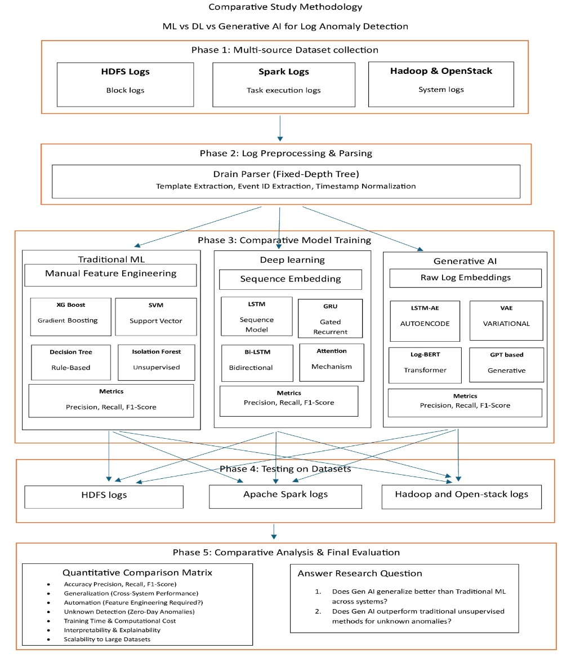
3.1 Phase 1: Multi-Source Dataset Collection
A multi-source repository is utilized to ensure rigorous comparative testing across heterogeneous environments.
- HDFS Logs: Collection of block logs.
- Apache Spark Logs: Collection of task execution logs.
- Hadoop & OpenStack: Collection of system logs.
3.2 Phase 2: Log Preprocessing & Parsing
Raw logs are processed using the Drain Parser, a Fixed-Depth Tree approach. The preprocessing involves template extraction, event ID extraction, and timestamp normalization.
3.3 Phase 3: Comparative Model Training
The study implements three parallel pipelines:
- Pipeline 1: Traditional ML: Relies on manual feature engineering. Models include Support Vector (SVM), Gradient Boosting (XG Boost), Rule-Based (Decision Tree), and Unsupervised (Isolation Forest).
- Pipeline 2: Deep Learning: Utilizes sequence embedding. Models incorporate Attention Mechanisms, Bidirectional Bi-LSTM, Gated Recurrent GRU, and Sequence Model LSTM.
- Pipeline 3: Generative AI: Leverages raw, self-supervised log embeddings. Models evaluated include GPT-based Generative, Log-BERT Transformer, Variational VAE, and LSTM-AE Autoencoder.
3.4 Phase 4: Cross-Platform Testing
To assess transfer learning capabilities, the trained models are tested across the collected datasets, specifically evaluating performance on HDFS logs, Apache Spark logs, and Hadoop/OpenStack logs.
3.5 Phase 5: Comparative Analysis & Final Evaluation
Models are assessed using a Quantitative Comparison Matrix focusing on metrics such as Precision, Recall, and F1-Score. The evaluation also measures Generalization (cross-system performance), Automation (feature engineering requirements), Unknown Detection (zero-day anomalies), Training Time, Interpretability, and Scalability to large datasets. This matrix will directly answer the core research questions regarding Generative AI's capability to generalize across systems and outperform traditional unsupervised methods.

Chapter 4: Results & Analysis
4.1 Baseline Performance (HDFS v1)
This section documents the initial benchmarking phase of the traditional supervised machine learning pipeline. Models were evaluated using a strict 80% training and 20% testing split on the HDFS log dataset. The dataset presents a severe class imbalance challenge, comprising 558,223 normal log vectors and 16,838 anomaly vectors. The 20% holdout test set contains a total of 115,013 instances, with 111,645 normal cases and 3,368 anomalies.
To address the severe class distribution disparity during training, the XGBoost classifier incorporated an automated minority class weighting adjustment via the scale_pos_weight parameter.
4.1.1 Quantitative Performance Metrics
The traditional supervised models demonstrated exceptional efficacy on the structured event-count matrix extracted from the HDFS logs. A consolidated comparison of the anomaly detection capabilities (Class 1) is presented in the table below:
Model | Anomaly Precision | Anomaly Recall | Anomaly F1-Score | False Positives (FP) | False Negatives (FN) | 5-Fold CV Mean F1
Support Vector Machine (SVM) | 0.9634 | 0.9994 | 0.9811 | 128 | 2 | $$0.9796±0.0016$$
XGBoost Classifier | 0.9985 | 0.9997 | 0.9991 | 5 | 1 | $$0.9979±0.0005$$
4.1.2 Statistical Validation and Robustness Testing
To ensure the models were capturing authentic semantic and logical relationships within the log event streams rather than capitalizing on basic statistical artifacts, two validation protocols were enforced:
- 5-Fold Cross-Validation: Both models demonstrated immense structural stability across multiple folds. XGBoost achieved a tight variance with a mean F1-score of $0.9979 \pm 0.0005$, while the linear-boundary SVM yielded a mean F1-score of $0.9796 \pm 0.0016$.
- Permutation / Shuffle Test: A data shuffle test was executed to intentionally break the structured alignment of the target feature dependencies. Upon shuffling, the anomaly F1-score for SVM plummeted to 0.0211 (with overall accuracy dropping to 35.56%). Similarly, the XGBoost anomaly F1-score collapsed to 0.0281 (with overall accuracy dropping to 28.23%). This absolute performance degradation confirms that the high baseline metrics are a direct product of the models successfully learning log correlation patterns.
[Shuffle Test Performance Collapse]
1.00 ─────────────────────────────────────────── (Baseline F1: ~0.98 - 0.99)
│
│
▼
0.02 ─────────────────────────────────────────── (Shuffled F1: ~0.02 - 0.03)
4.1.3 Comparative Analysis of ML Baselines
While both architectures verified that traditional supervised learning can handle known, structured log types effectively, XGBoost distinctly outperformed SVM across all key parameters.
SVM produced 128 false positive alarms and missed 2 true anomalies within the test framework. In contrast, XGBoost minimized false alarms down to a mere 5 instances and missed only a single anomaly ($FN = 1$) out of the entire test pool. This variance highlights XGBoost’s superior capacity to construct non-linear decision boundaries and complex splits across event distributions, whereas the linear limits of the SVM boundary result in a higher false-alarm rate under heavily skewed data conditions.
Next Steps for Your Deep Learning and GenAI Sections:
Now that your traditional ML baseline is completely locked in and documented for final thesis report asad msai 4.docx, we can use these numbers as the ultimate benchmark. When you run your Deep Learning (LSTM/GRU) or GenAI (Transformers/Autoencoders) scripts, we will be looking to see if they can match this raw accuracy without needing the manual feature engineering that XGBoost relies on.

